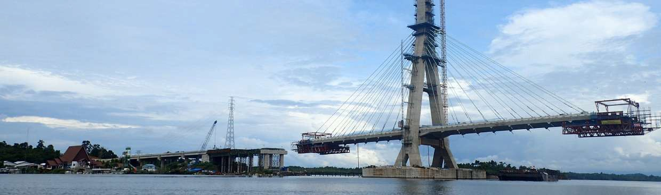
NEWSLETTER
Civil society coalition for coastal and small islands justice

IN THE MIDST OF THE COVID-19 PANDEMIC, THE EAST KALIMANTAN LOCAL GOVERNMENT AND PARLIAMENT ARE RUSHING TO IMMEDIATELY PASS THE PROVINCIAL BILL ON COASTAL ZONE AND SMALL ISLAND ZONATION PLAN

ECOLOGICAL EXISTENCE & FATE OF FISHERS QUESTIONED
In these times of distress amid this Covid-19 pandemic, the East Kalimantan Province Government and Parliament are instead pushing to pass the Provincial Bill on Coastal Zone and Small Island Zonation Plan (RZWP3K) that will seize the living space of coastal communities and destroy coastal and seascapes. The Special Committee is aiming to hold a hearing on 16 June 2020 and will soon pass the Bill into Provincial Regulation.
We the Civil Society Coalition for Coastal and Small Islands Justice have a critical note on the work of the Local Parliament Special Committee, which to date has never held public consultations, especially with coastal and fishing communities in East Kalimantan Province. This clearly violates Law No. 27 of 2007 juncto Law No. 1 of 2014 on the Management of Coastal Areas and Small Islands, specifically Article 7 which states that in the formulation of the management plan for coastal zone and small islands, the Local Government involves the public, and Article 14 stating mechanism for the formulation of the RZWP-3-K is carried out by including the public. The area being mapped is the area where the coastal community lives, and so their lives will be directly affected if this bill is passed. There is also a potential socio-cultural shift in the East Kalimantan coastal community, with the loss of fishing villages and lack of space for fishers to catch fish. In the future, the coastal community in East Kalimantan will only be spectators looking at their own seas.
The Civil Society Coalition for Coastal and Small Islands Justice sends an ultimatum to the current ongoing deliberations of the East Kalimantan Provincial Zoning Bill for Coastal Areas and Small Islands and rejects of this bill. We urge the East Kalimantan Provincial Parliament’s Special Committee to stop deliberations for this bill. The rationale is that this Zoning Bill is created not in the interest of coastal communities, specifically fishers, but instead to serve for the interest of industry investments.
We have compiled the following ten pointers from the RZWP3K Bill that will be unsuitable for implementation in East Kalimantan coastal areas and waters:
- In the East Kalimantan RZWP3K Bill, communities must obtain location and management permits from the Local Government to manage and utilize coastal areas and small islands (Article 46). This contradicts Article 60 of Law No. 1 of 2014, which provides communities with the rights to propose traditional fishing grounds in RZWP3K. The Regulation of Minister of Marine Affairs and Fisheries No. 23/PERMEN-KP/2016 on Coastal Areas and Small Islands Management Planning emphasizes the importance of area of livelihood and access for small-scale and artisanal fishers in the 0-2 nautical mile distance. Meanwhile, the East Kalimantan RZWP3K Bill Spatial Allocation Map does not include a fishing zone (0-2 miles) for communities in Balikpapan Bay. Fishing ground is important for fishers. Instead, areas along the estuary are designated to support industrial zones.
- The public’s current activities to support sustainable tourism is not accommodated in the RZWP3K Bill. In Article 11 Par. 2 of the Bill, the coast from 0 to 2 nautical miles is allocated for conservation areas, livelihood and access to small-scale fishers, artisanal fishers, small-scale fish farmers, small-scale salt farmers, sustainable marine tourism, and public infrastructures. These narratives conflict with the Spatial Allocation Map in the exclusion of community-based mangrove tourism management in Mentawir Village and mangrove center in Balikpapan Bay.
- This East Kalimantan RZWP3K Bill is developed to accommodate investment interests over the needs of the public. This is a clear violation of Article 33 Par. 3 of the 1945 Indonesian Constitution that mandates land and water, and the natural resources found therein, shall be controlled by the state and shall be exploited for the maximum benefit of the people, not for the benefit of only a few, such as the industry investment players who are clearly behind the destructions. We have noted the following projects in the Bill:
Firstly, a 752.180 ha reclamation project in Balikpapan Bay estuary. Another reclamation project is situated in the coastal area, measuring 528.91 ha, as well the oil refinery reclamation project in South Bontang Subdistrict, Bontang City of 41.72 ha and 181.55 ha;
Secondly, a mining project in coastal areas and small islands, including oil and natural gas mines, covering 46,758.21 ha;
Third, port zone connected to Special Terminals for shipping oil, natural gas, and coal mining, as well as plantation activities. The special terminals found along the coast target Apar Bay Nature Reserve, covering 3,372.67 ha and Adang Bay in Paser District with an area of 19,864.01 ha, as well as the critical ecosystem in Balikpapan Bay covering 46,153.91 ha.
Fourth, the East Kalimantan coastal karst landscape did not escape the clutches of the mining industry. The karst ecosystem, which is a source of fresh water for coastal communities in the northern part of the province, will be disrupted with the allocation of 65,460 ha mining permit in the province’s coastal karst ecosystem. The Sangkulirang-Mangkalihat karst ecosystem must be protected. Part of Berau and East Kutai Districts, the ecosystem has a 1.125 km coastline and an area of 1.9 million hectares out of 3.3 million hectares located along the coast (P3EK, 2016);
Fifth in the waters along the northern to southern coast of the East Kalimantan province, 1.3 million ha out of 3.7 million ha waters of the province (0-12 nautical miles) have been allocated for oil and gas mining. Ironically, 719,000 ha from this area overlaps with existing artisanal fishing grounds.
Sixth, the East Kalimantan RZWP3K Bill accommodates plans for special terminals for the industrial, trade, energy, mining, agriculture, and fisheries sectors’ interests. In the map supplemented, as many as 121 special terminals will be constructed. In the text of the Bill itself however the number of these terminals are barely mentioned. Therefore, there are conflicting substances in this Bill.

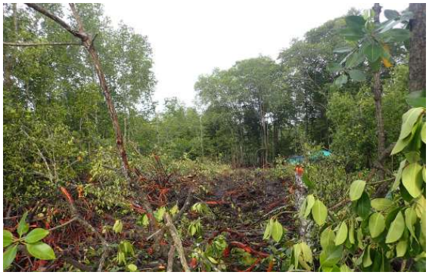Mangroves destroyed by the use of excavators in mangrove forests in the Greater Dussang area (20/04/2020). Coalition Documentation.

- This Bill does not stipulate the protection of mangrove ecosystem into policy analysis processes. Mangrove ecosystems in the East Kalimantan coastline, covering 244,437.32 ha and distributed in nearly every districts and municipalities, is not regulated in this Bill. This Bill contradicts the policy directive of Presidential Regulation No. 73 of 2012 to raise the protection function of mangrove ecosystems that the local government must execute. Another critical policy directive to enforce is the prohibition of the conversion of mangrove ecosystems into other land uses such as industry, plantation, mining, and other cultivation activities. But in Balikpapan Bay, mangrove, sea grass, and coral reef ecosystems will be converted into Work Zones (DLKr) or Interest Zones (DLKp), industry, plantations, and timber plantations.
- Critical areas support the conservation of protected species such as the Irrawady dolphin, dugong, and proboscis monkeys, that do not live in protected areas. The majority of wildlife in Balikpapan Bay are protected under the Regulation of Minister of Environment and Forestry No. 106 of 2018 on the Protection of Flora and Fauna. Critical habitats for protected species have been nearly entirely allocated for industrial purposes.
- This RZWP3K Bill is weak in the mitigation of disasters such as flood risks, flood vulnerability, oil spills, even potential tsunamis. The spatial allocation map fails to apply disaster mitigation approach in its development. Coastal areas and mangrove ecosystems identified as flood risk and flood prone areas are not considered in the analysis processes. There are no approaches as stipulated in the Government Regulation No. 37 of 2012 on River Basin Management. Balikpapan Bay, the estuary of more than 50 sub-river basins, is assessed as separate upstream and downstream entities. There are no lessons learned from the oil spill in the Balikpapan Bay. Cultivation needs are placed above protection functions. This puts the lives of communities and coastal and marine resources on the line.
- At the same time, only 25.22 ha is allocated for fishing community settlements for the entire fishing community, comprising 137,553 households, with 47,477 capture fisher households and 90,076 aquaculture households (Article 8).
- As much as 2,605,046.40 ha is allocated for catch fisheries, but its location is too far for artisanal or small-scale fishers (for one day fishing). Artisanal fishers can only reach approximately 3 nautical miles. Meanwhile, areas with high fisheries potential along estuaries and coastal areas are allocated for mining, ports, reclamation, and other industries in the RZWP3K Bill. This will cause a loss of livelihoods for fishers in the province.
- Local communities’ roles are not accommodated in the monitoring of coastal and marine resources as part of an integrated coastal management. The Bill does not include clauses regulating public participation in monitoring, as mandated in Law No. 27 of 2007 juncto Law No. 1 of 2014 on the Management of Coastal Areas and Small Islands, specifically Article 36 Par. 6. In fact, the communities’ achievements in Balikpapan Bay monitoring has been recognized and appreciated by the Balikpapan City Government and City Parliament through issuance of a certificate for one of the community members.
- This RZWP3K Bill appears to neglect inputs and recommendations of the Balikpapan City Government to develop Balikpapan Bay as a local marine conservation area. Through Letter of Recommendation No. 660/0117/DLH dated 31 January 2019 from the Balikpapan City Government to the East Kalimantan Governor, Balikpapan Bay was recommended as a conservation area. The RZWP3K Bill in Article 11 Par. 2 designates 0-2 nautical miles of the East Kalimantan coastline for conservation area. However, the Spatial Allocation Map shows that the bay is prioritized for ports (DLKr/DLKp).

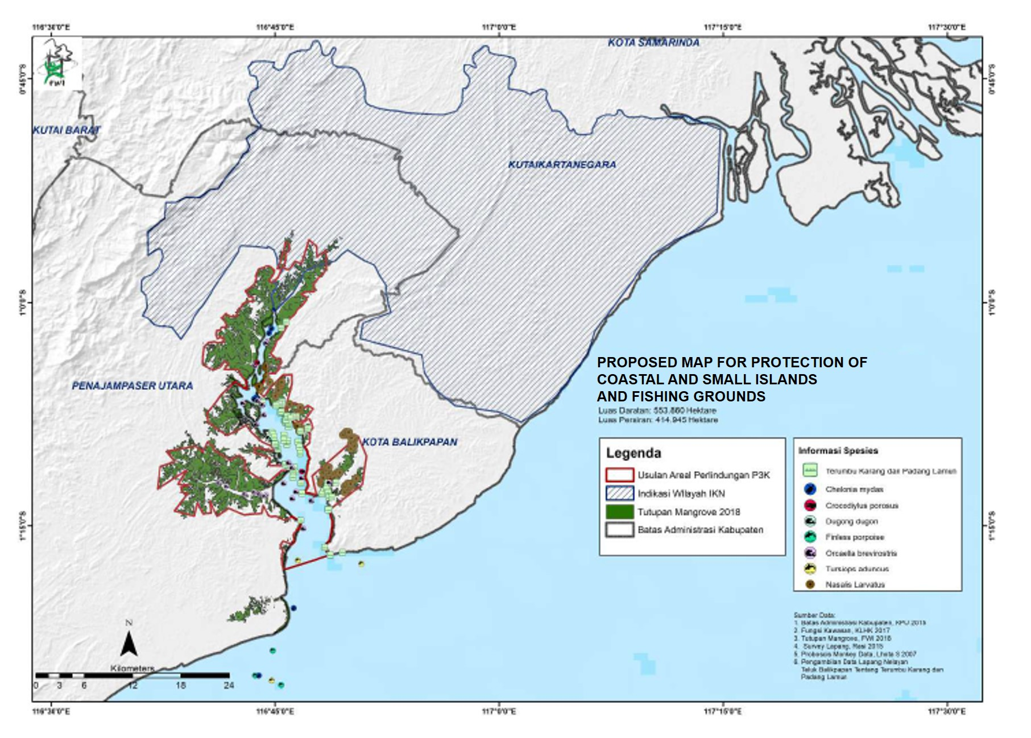
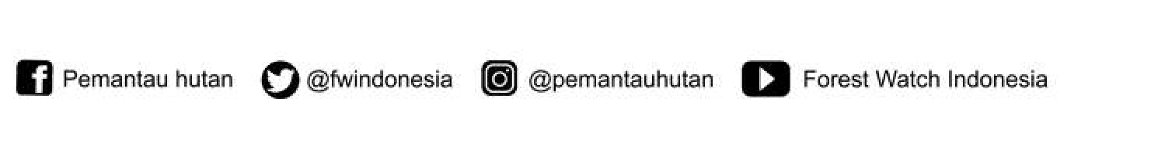

Newsletter © Mei 2020

Secretariat Address:
- Office of the Coastal Working Group
Jl. Ruhui Rahayu Perum Rengganis Blok 2A No 85 Balikpapan
Contact Person: Mappaselle +62-813-4874-4716 (East Kalimantan Hub)
- Forest Watch Indonesia (FWI)
Jl. Sempur Kaler Nomor 62 Kelurahan Sempur, Bogor.
Contact Person: Anggi Putra Prayoga +62-8229-8317-272 (National Hub)

“The RZWP3K Bill will not achieve the objectives of its creation and ratification. This Bill is so destructive in coastal areas and small islands. It is no different from the East Kalimantan Province Spatial Plan destroying the land. The objective of creating a clean and sustainable environment is not translated in the RZWP3K Bill spatial allocation map!”

CIVIL SOCIETY COALITION FOR COASTAL AND SMALL ISLANDS JUSTICE

